"Kyiv Vocational College of Communication"

Cyclic Commission of Computer Engineering

EXECUTION REPORT

**Work - Case #5**

**from the discipline: "Operating systems"**

**Topic:** WORK-CASES IN LINUX

a list of additional practical tasks

from the discipline "Operating Systems"

It was performed by students of the RPZ group - 03B

Team 6: Sichkar Maxim,

Brytyuk Bohdan

Kyiv 2023

**Work-case 5**

**1. Consider the questions and give answers:**

* **Very often occurs when working with a personal computer peripheral equipment must be connected. On the example of a printer and flash drives, describe what mechanism the Linux OS has for working with them.**

Linux has a powerful and flexible system for managing peripheral devices such as printers and flash drives. The operating system uses a combination of hardware detection, device drivers, and user-space tools to provide a seamless and efficient user experience.

When a peripheral device is connected to a Linux system, the hardware detection subsystem automatically detects the device and loads the appropriate device driver. The device driver is a piece of software that allows the operating system to communicate with the device and perform various operations such as printing, reading, or writing data.

In the case of a printer, Linux typically uses the Common Unix Printing System (CUPS) to manage print jobs. CUPS is a printing system that allows users to easily print documents from their applications, regardless of the printer's make or model. When a user sends a print job to the printer, CUPS communicates with the printer's device driver to translate the print job into a format that the printer can understand.

Similarly, when a user plugs in a flash drive, Linux automatically detects the device and mounts the file system. This allows the user to access the files on the flash drive as if they were on the local hard drive. Linux supports a wide range of file systems, including FAT32, NTFS, and ext4, which are commonly used by flash drives.

Linux provides a robust and reliable system for managing peripheral devices, allowing users to seamlessly connect and use their devices without having to worry about complex configuration or installation procedures.

* **What is the essence of the installation operation, why is it used and how?**

The installation operation refers to the process of preparing and configuring a software application on a computer system or device so that it can be used by an end user. The essence of the installation operation is to make the software program available for use by setting up all the necessary files, libraries, and configurations required for the program to function properly.

Installation is used to ensure that software applications are correctly installed on the computer system and can work properly. Without proper installation, the software may not work properly or at all. The installation process is usually performed by an installation program that is designed to guide the user through the installation process step by step.

The installation process usually consists of the following steps:

* Pre-installation checks: The installation program checks the computer system to ensure that it meets the minimum system requirements for the program. If the system does not meet the requirements, the installer can warn the user or stop the installation process.
* Configuration: The installer configures the software by creating directories, setting permissions, and modifying configuration files. This step ensures the correct operation of the program in the system.
* Copying files: The installer copies all the necessary files and libraries required for the program to work properly. This step ensures that all required files are available on the system.
* Post-installation checks: The installer performs some final checks to ensure that the software is installed correctly and can run without problems.

In conclusion, the installation operation is essential for software programs to function properly on a computer system or device. The process involves setting up, copying and verifying all the necessary files and configurations required for the program to work properly.

* **Why the difference when working with peripherals in Linux OS and Windows OS?**

The difference when working with peripherals in Linux OS and Windows OS lies primarily in the way the two operating systems handle device drivers and hardware support.

In Linux, device drivers are typically built into the kernel or loaded as modules during system boot. This means that Linux has a large number of device drivers available by default, and most peripheral devices can be used without the need for additional driver installation. Additionally, Linux supports a wide range of file systems, which allows it to work with different types of storage devices such as flash drives or external hard drives.

On the other hand, Windows relies heavily on device drivers that are installed separately from the operating system. When a new device is connected to a Windows system, the device driver must be installed before the device can be used. This can sometimes result in compatibility issues, particularly if the device is not supported by the operating system or if the correct driver is not available.

Another difference is that Linux is often more lightweight and customizable than Windows, which can make it a better choice for running on low-power devices such as Raspberry Pi or other embedded systems. Linux can also be more stable and reliable in some cases, particularly for server or high-performance computing applications.

**2. Connect to your virtual machine with the installed Linux OS flash drive**

**and printer (if possible) and through the GUI copy one**

**file from a flash drive to a virtual machine and print it (the same steps**

**repeat, but with a different file and through commands in the terminal).**

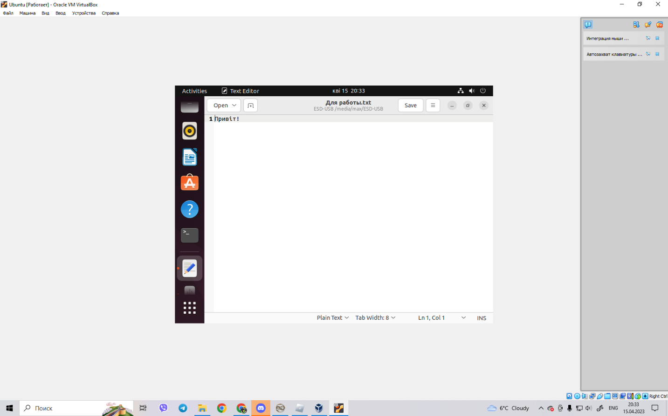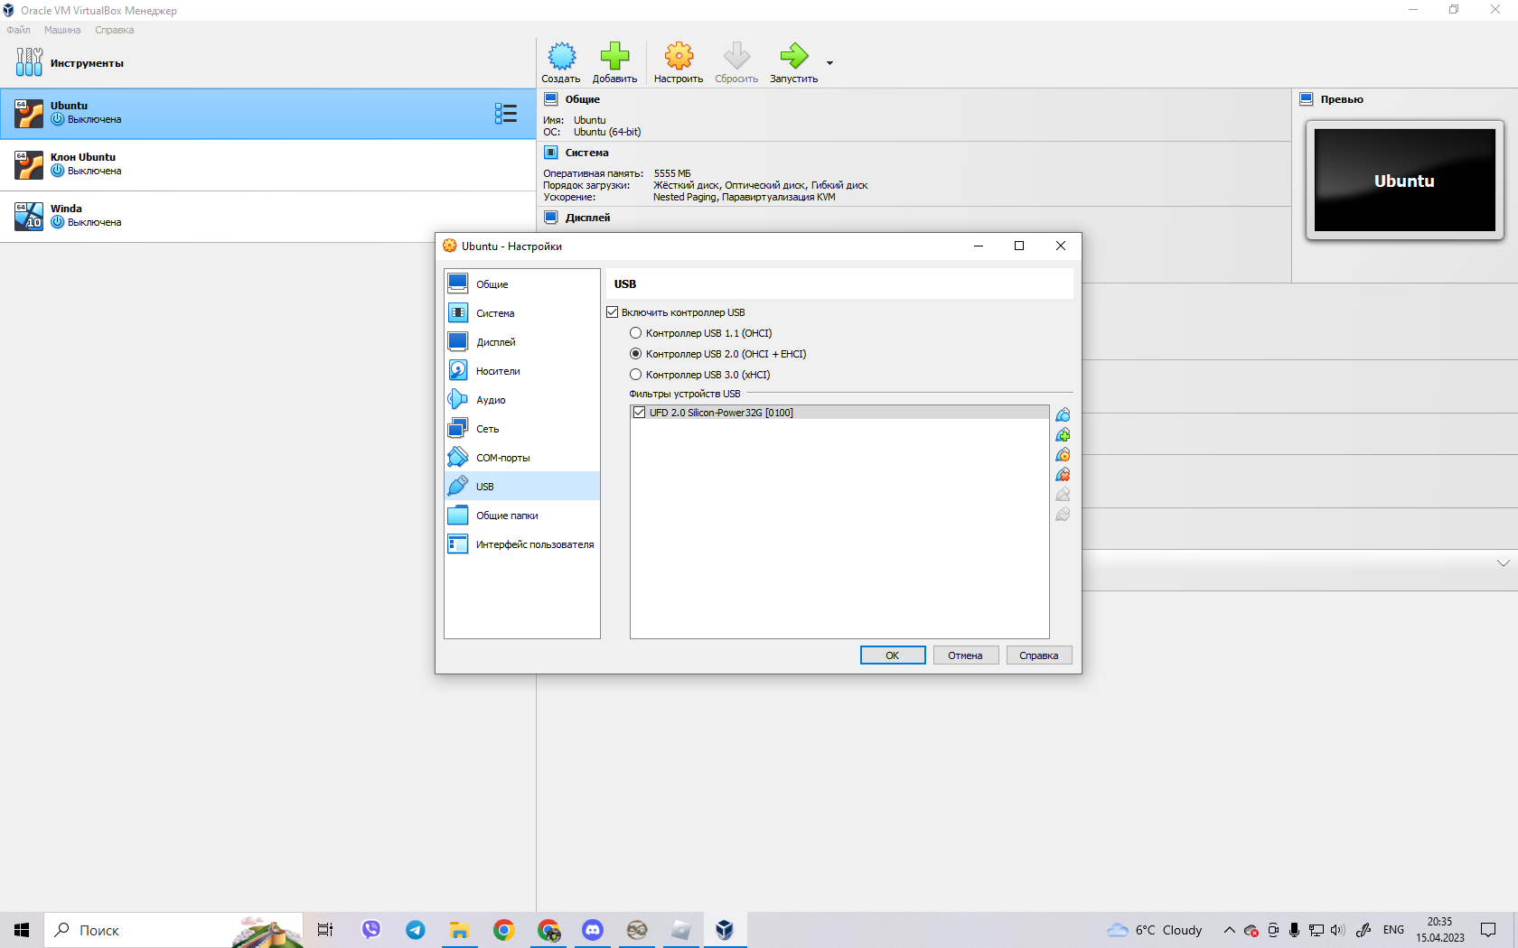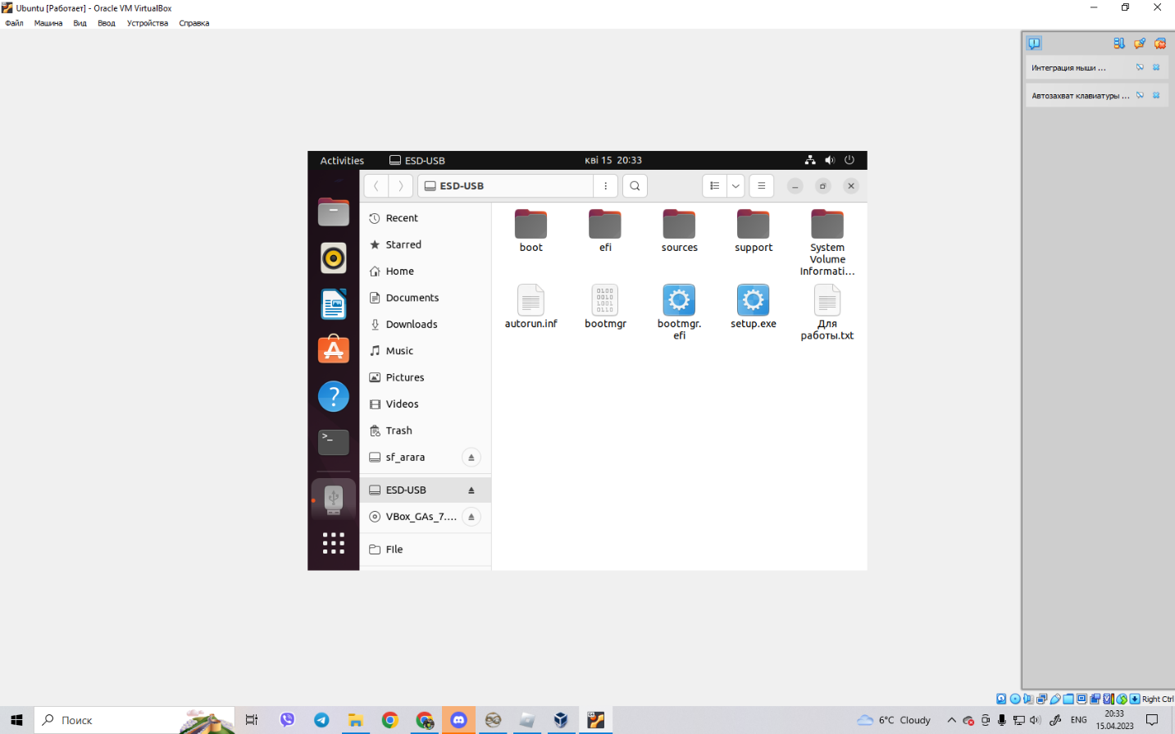

**Conclusion: I learned how to use a flash drive in virtual box**